**Hospital data set analysis by Pratik Nandanwar (Newton POWER BI project)**

**Objective questions-**

**Question 1 –**

1. In analysing the hospital dataset with Power BI, ensure data cleaning to address inconsistencies and missing values before further analysis.

ANS-

For starting the data analysis, I started with data cleaning.

1. joined the two tables by using merge queries so as to have all the data in one table.
2. reordered the columns in a way which would make sense while viewing at the table.
3. split the column of data and time in separate column for the convenience while analysis.
4. merged the column of first and last name of patient as it was unnecessarily placed in 2 columns.
5. Data types of all columns were checked and if needed changed accordingly.
6. In the column of satisfaction score – average satisfaction score that is 5 from patients was replaced on the place of blank and null values.
7. Conditional columns were created for bucketing time group and age group.

**Question 2 –**

**Assess the Average Waiting Time:** Analyse the patient wait times to identify the average duration a patient spends before receiving care.

**Ans-**.

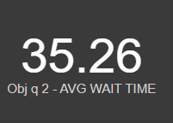

* **Average** wait time was calculated by adding a new measure in which DAX function of AVERAGE was used which came out to be 35.26 Minutes(could also be done directly in report view adding a new visual and choosing patient wait time column and averaging it.
* **Average** wait time can be can be influential manipulation factor and indicator of various things like patient satisfaction, workflow efficiency in hospital, staffing levels etc

**Question 3 –**

**Visits by Department Referral:** Calculate the total number of visits to each department based on referrals to understand which departments are most frequently visited.

**Ans**

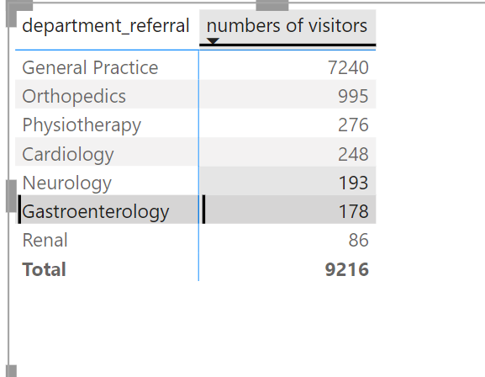 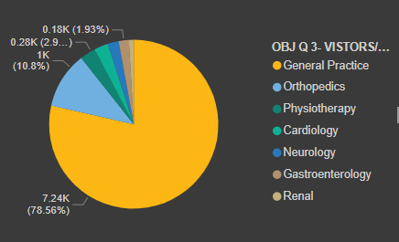

* **The** above-mentioned table gives the numbers of visitors as per departments.
* As it can be seen most visited departments are of **general practice & orthopaedics.**
* **By the** number of visits/department it can be a indicator to public health trends ,potential areas for hospital to allocate resources etc .

**Question 4 –**

**Q- Patient Visits by Age Group:** Segregate patient visits according to different age groups to see which demographics utilize healthcare services the most.

**ANSWER -**

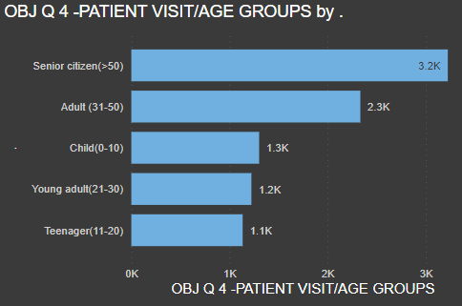

* From the graph above the demographics of **adult & Senior citizen** utilizes the healthcare services the most.
* The age groups were divided in a specific group and the data was analysed. This indicates the age related health issues, primary care that should be taken as age progression, importance of **Preventive Care and Health Maintenance,** Monetary planning that should be planned.

**Question 5 –**

**Average Satisfaction by Demographics:**

Determine the relationship between patient satisfaction scores, their age groups, and racial backgrounds to pinpoint areas for improvement in patient experience.

Answer

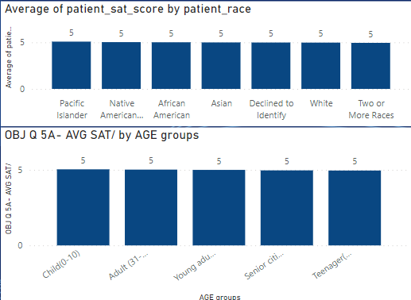

* All the age groups and races has reported nearby a average satisfaction score of 5 .
* This satisfaction score is alaraming for focusing on various aspects of hospital services for increasing the ratings as a score of 5 out of 10 indicates a mid – level service .

**Several hospital services/steps that can be taken is for improving is –**

* Comparing the ratings with the relavent high rated hospital services in a valid radius and chalk out the reason for difference.
* Taking for detailed feedback from patients for getting to know pinpointed areas to improve.
* Specific training and awareness for the staff of hospital for equiping the staff enhancing patient expirience.
* Continious monitoring and quick actions on the results , this includes stringent monitoring on the planned objectives and quick reflective improvement or actions to update/upgrade it accordingly .

**Question 6 –**

The hospital's managing director seeks to evaluate the **revenue of each department** to understand how much revenue is generated by each.

**Answer-**

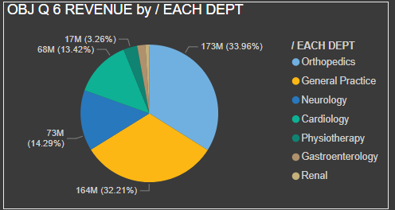

* **Orthopaedics & general practice** are the major contributor for the **revenue generation of 173M and 164M** respectively.
* As orthopaedics and general practice departments are major contributor in revenue this information can be used as leverage for further strategic and decision making planning like which doctor and staff is overworked in this 2 departments so as to increase the staffing and doctors , or which physical and machinery amenities can be provided to accommodate more patients by looking upon the wait time of patient as well to reduce this patient wait time. Shortcomings of department can be analysed and accordingly training can be provided.

**Question 7-**

Q- Is there any relation between the number of visits and Gender of the patients.

ANSWER-

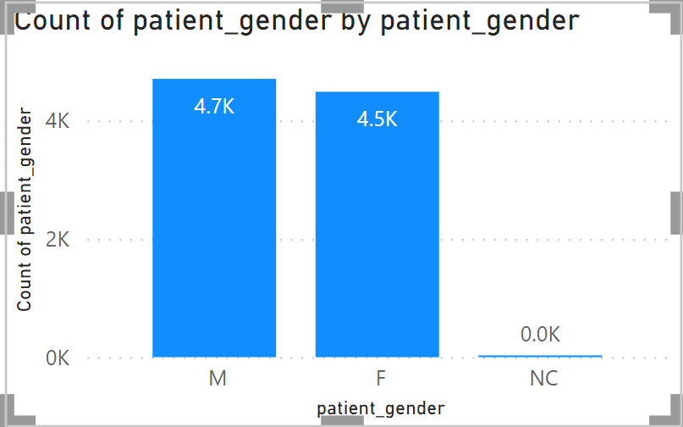

* No considerable relationship between number of visits with respect to gender is seen. The number of visits of male and female have minute difference of 200 between them hence no relationship can be established.
* However services and amenities for every gender should be provided within the hospital area like washrooms, rest room , feeding rooms for infants , new born for women’s , food facility as per demand .

**Question 8-**

Which department is charging the highest appointment fees in general?

Ans-

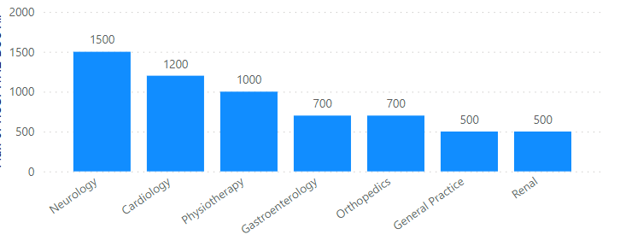

* **Neurology** has the highest and cardiology has the second higest appointment fees.
* Itis important to devise the justification of high fees by these departments making sure the rates are competitive with the market and not overpriced .
* Also looking at the number of visitors the department of neurology and cardiology are towards lower sides. The reason behind this should be analysed if the pricing or any other service is the reason behind the low number of visits to update/upgrade accordingly.

**Subjective questions-**

Question -1

**What is the relation between patient wait time and satisfaction scores?**

Investigate whether longer wait times are associated with lower patient satisfaction across various departments.

Ans –

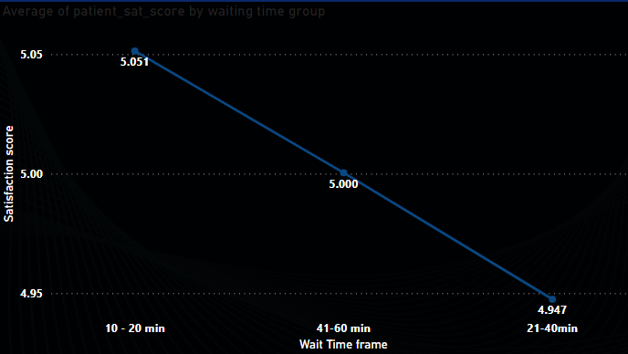

* From the data, the wait time was grouped in the brackets of

Lower wait time = 10-20 minutes

Medium wait time = 21-40min,

High wait time = 41-60 min.

* And plotting it with respect to average satisfaction score it was seen that when the waiting time at hospital is 10-20 mins which is less compared to further wait timings, the satisfaction score average is greater.
* And when the waiting time at hospital increases the satisfaction score average drops.
* However, it may be due to various reasons, but many patients did not report satisfaction score and many data points for satisfaction scores were blank, and for those blanks average satisfaction scores were considered hence there is visually low difference between the average satisfaction data labels.
* It is evident that lower waiting time at hospital results to higher satisfaction scores from the available data as well it is a general phenomenon observed too. Hence measures should be planned and taken by authority/management by aiming for a patient should need minimum waiting time when he/she comes to hospital.

**Suggestions –**

**Some measures that can be planned are –**

* **Optimization in appointment taking process** – This would help maximum utilization of available time slots .
* **Integrating online and digital services –** Using digital services functionality which would enable patient to access the online hospital scheduled, registrations, check- in , keeping information handy, reminders for appointments , low and high rush hours and days viewing etc can be done.
* **Training the staff –** Staff should be equipped for high rush hours and days to handle and communicate the load effectively.
* **Effective resource allocation and availability –** numerous resources like staffs, doctors, waiting rooms, washrooms etc should be strategically planned and allocated so if this is done there will be a smooth check in and check out process for patient and the wait time would be reduced.
* **Online portal** for consultation and follow up in cases where patient would not need to come to hospital. This would also lessen the load on hospital and the wait time for physically coming people would be lowered.

**Conclusion –**

* **There is a evident inverse relationship** for patient waiting time and satisfaction scores.
* Both factors of patient wait timing and satisfaction score are important to look upon and strategically manage for improving overall experience of patient and reducing the load for hospital management too.
* Certain suggestions are made for implementation of the matter for achieving the objective of lowering the waiting time and increasing the satisfaction score.

Question -2

**Q- How do patient demographics affect the frequency of visits to different departments?**

Analyse visit patterns to see if certain age groups or races are more likely to be referred to specific departments.

Answer-

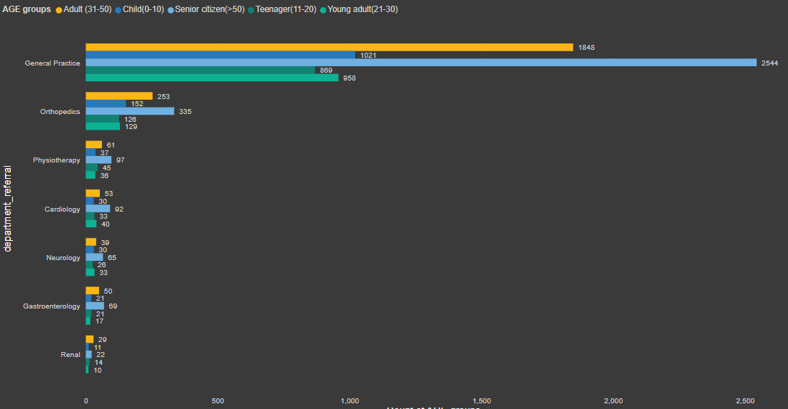

* To analyse the department patterns as per age group towards different hospital departments, clustered bar chart was used. We can see the distribution of various age group for various departments.

GENERAL PRACTICE –

GENERAL PRACTICE department can include

* Primary health issues and care like preventive check-ups, flu like conditions, some chronic general conditions .
* Management of chronic issues like allergies, diabetes etc
* Minor or injury cases
* Primary check-up for referral to specialist etc.
* TREND –
* Senior citizen (>50) & Adult (31-50) – highest visits
* Teenagers (11-20) & young adult (21-30)- lowest visits
* In general practice department the highest visits are of age group having age greater than **50 years** and lowest are of **teenagers** aged 11-20 this can be due to after a certain age the immunity level of a human body decreases whereas in 11-20 general and chronic issues are not prominent as the human body is young and growing and has a good immunity against general conditions.
* As well the chronic conditions come after a certain age in nominal conditions hence this is the reason for high traffic towards old aged people and less traffic of 11-20 years at general practice.
* The second highest is the adult age group of age 31-50years and post that children’s aged 0-10 . The reason for this is can be in adult age group, due to being stressed and overworked certain conditions prevails. Many times, in early ages of adult groups especially high work stress condition group undergo many issues regarding health but due to unavailability and shortage of time due to personal and professional responsibilities they either don’t take care of these conditions, or fail to take care or even ignore the conditions at all even in a early preventive stages and then when these conditions gets very severe only then they care about it.

**Orthopaedics –**

* Trends –
* Senior citizen (>50) & Adult (31-50) – highest visits
* Teenagers (11-20) & young adult (21-30)- lowest visits
* Children (0-10) – medium
* The reason for this trend can be because – growing age generally comes with bones related issues .
* Whereas children being in medium category is because children this aged are in growing stage , many cases happens of falling , or issues while playing and due to being in early stage the foundation of bones are not in developed state and prone to injuries .
* Physiotherapy
* Physiotherapy generally follows with orthopaedics department so as to for recovery in suggested cases by orthopaedic doctor .
* Generally need of physiotherapy for recovery prevails post a certain age or roughly 30-35 + as because it gets hard to recover from bones fractures and ortho issues on own basis of body’s recovery power . hence trend can be seen that adult and senior citizen to be at highest .

**Cardiology**

Trend

* Adult & senior citizen – higest
* Young adult – medium
* Child & teenager – lowest
* Evidently, cardiology is a branch of medicine that deals with disorders of the heart and the cardiovascular system. Which generally(amongst) a factor is a age dependent issue. Hence the trendline.

**Conclusion –**

* In **general practice** , age group of adult and senior citizen that is age after 30 comes most .Teenagers (11-20) & young adult (21-30) comes lowest and there are medium number of cases of Children (0-10) .
* In **orthopaedics** ,age group of adult and senior citizen that is age after 30 comes most .Teenagers (11-20) & young adult (21-30) comes lowest and there are medium number of cases of Children (0-10) .
* In **Physiotherapy ,** Adult and senior citizen are mostly referred ,child and young adult are referred lowest, teenagers has medium referrals.
* In **Cardiology,** Adult and senior citizen are mostly referred ,child and teenager are referred lowest, young adults has medium referrals.
* In **Neurology ,** age group of adult and senior citizen that is age after 30 comes mostly referred .Teenagers (11-20) are referred lowest and young adult (21-30) Children (0-10) have medium numbers of referrals.
* In **Gastroentology ,** age group of adult and senior citizen that is age after 30 comes mostly referred . Young adult are referred lowest and Children (0-10) Teenagers (11-20) have medium numbers of referrals.
* In **Renal** age group of Adult & senior citizen are referred the highest ,Young adult are referred the lowest and Child & teenager have medium referral.
* To analyse the department patterns as per Race group towards different hospital departments, clustered bar chart was used. We can see the distribution of various Race group for various departments.

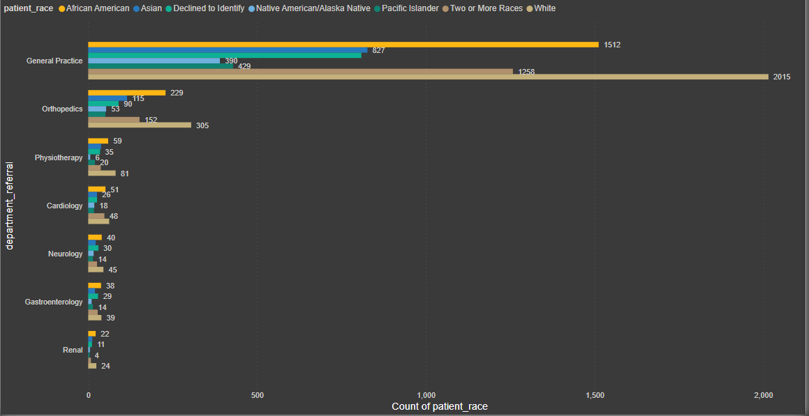

* In **General practice** ,white and African American has been referred the highest ,lowest is native American/alaska native and pacific islander and Asian, 2 or more identity & declined to identify comes in medium referred range.
* In **Orthopaedics** ,white and African American has been referred the highest ,lowest is native American/alaska native and pacific islander and Asian, 2 or more identity & declined to identify comes in medium referred range.
* In **Physiotherapy**, white and African American has been referred the highest, lowest is native American/alaska native and pacific islander and Asian, 2 or more identity & declined to identify comes in medium referred range.
* In **Cardiology** , white and African American has been referred the highest, lowest is native American/alaska native and pacific islander and Asian, 2 or more identity & declined to identify comes in medium referred range.
* In **Neurology**, white and African American has been referred the highest,lowest is native American/alaska native and pacific islander and Asian, 2 or more identity & declined to identify comes in medium referred range.
* In **Gasteroentology**, white and African American has been referred the highest,lowest is native American/alaska native and pacific islander and Asian, 2 or more identity & declined to identify comes in medium referred range.
* In **Renal**, white and African American has been referred the highest,lowest is native American/alaska native and pacific islander and Asian, 2 or more identity & declined to identify comes in medium referred range.

**Conclusion –**

A steady pattern through out every department can be seen in the number of referrals where

* White and African American has been referred the highest.
* Native American/Alaska native and pacific islander has been referred the lowest.
* Asian, 2 or more identity & declined to identify comes in medium referred range.

Question -3

**Is there a noticeable trend in the volume of patient visits throughout the year?**

Examine patient visit data to identify any seasonal trends or particular months with increased healthcare facility usage.

Ans –

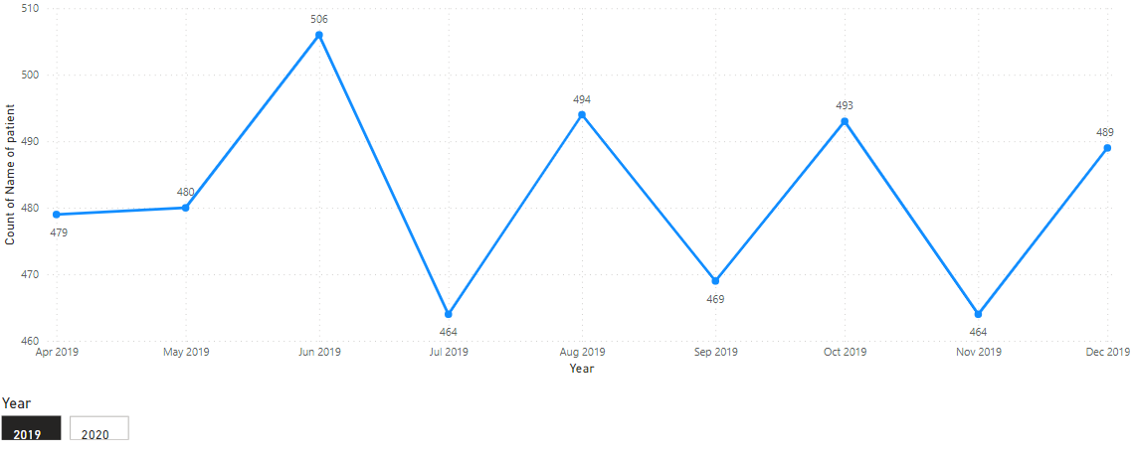

* As per the graph, it can be seen that in the year of 2019, April & may had a constant frequency of visits .
* However the numbers of visits increased in month of June which can be due a any seasonal change as in month of June the respiratory infections, allergies, and other conditions associated with the transition from spring to summer could lead due to which the need for healthcare increased.
* A subtle decline can be seen towards the end of the year which can be due to the holiday and festive season, people avoid any non-urgent medical visits as all are busy in preparations for holidays or are on vacations. Due to preplanned vacations people also delay the surgeries or any such medical procedures generally.

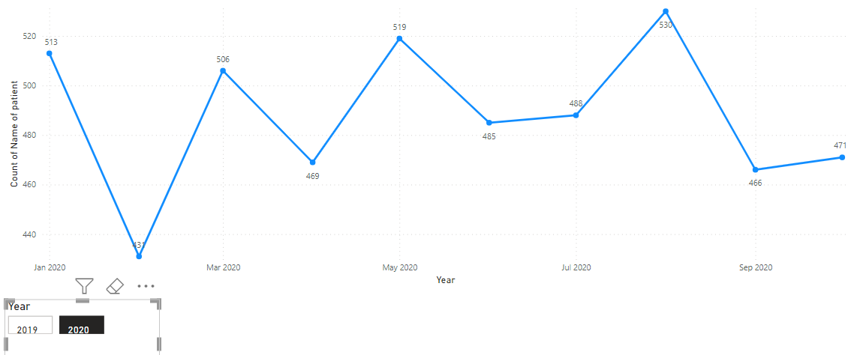

* In year 2020, January the number of visits increased more compared to last couple of months of 2019.
* This can be the delayed visits of the end year months from 2019 in which people avoided non urgent visits to hospitals or most people renews their insurance in start of year and they were waiting for January. Availability of doctors also can be the reason for this jump in volume because December month is likely to be a holiday month for all resulting in unviability of doctors or staff shortage in December.
* But after the month of January the visits dropped. This can be because the treatment of patients which was going on from last months be completed or the adverse change in the season and weather avoids the people from walking in to the hospital.
* Post the month of February a constant rise in the numbers could be alternatively seen till august month and post august month the volume of visits again dropped.

**Conclusion**

Yearly comparison

Compared to 2019,

* There is not a significant increase or decrease in number of visits, a slight fluctuation on 0-25 ranged visits can be seen.
* Certain patterns like decrease of volumes during end of year, sudden jump in first month of year, seasonal changes can be seen.
* Arrangements and planning can be strategically planned as per the seasonal and monthly patterns observed like the hospital can reduce or give holidays to staff during the end month of year but they had to be prepared for the start January month of the year. There is no abnormal rise or dip in the volume compared on a yearly level so no new hiring is needed for the staff . Doctor hiring may be needed to reduce the waiting time of the patient depending upon the circumstances. Any construction, repair, renovation work can be done during this lower rush days or months.

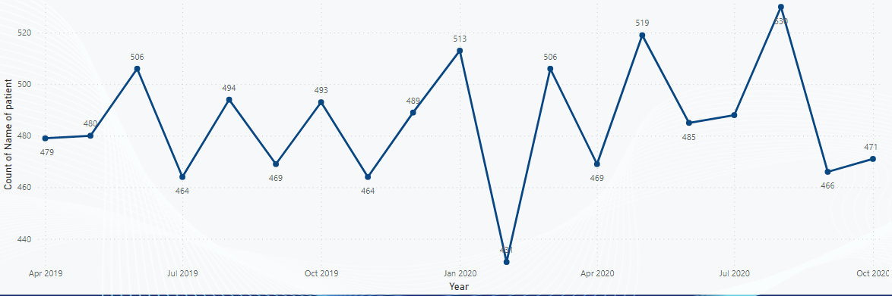

* For no change in volume in collectively both year factors like ,
  + Actual, no significant increase or decrease in demand,
  + No growth in hospital infrastructure therefore hospital can’t accommodate more patients
  + No new hiring done for doctors or other staff
  + Market saturation i.e there may be already enough services to meet the demand.
  + But the average wait time not being extremely high is still comparatively high so there may be saturation but not on a high level ,which means there is still scope left for growth.
  + Stagnant or not keeping up with market upgrades in service offerings.
* All mentioned points should be assessed by management to look for what is the actual reason for no significant change in volume and make decisions accordingly.

Question -4

Which age groups report the highest and lowest satisfaction scores?

Calculate the average satisfaction scores within each age group to identify which age demographics report the best and worst experiences.

Ans –

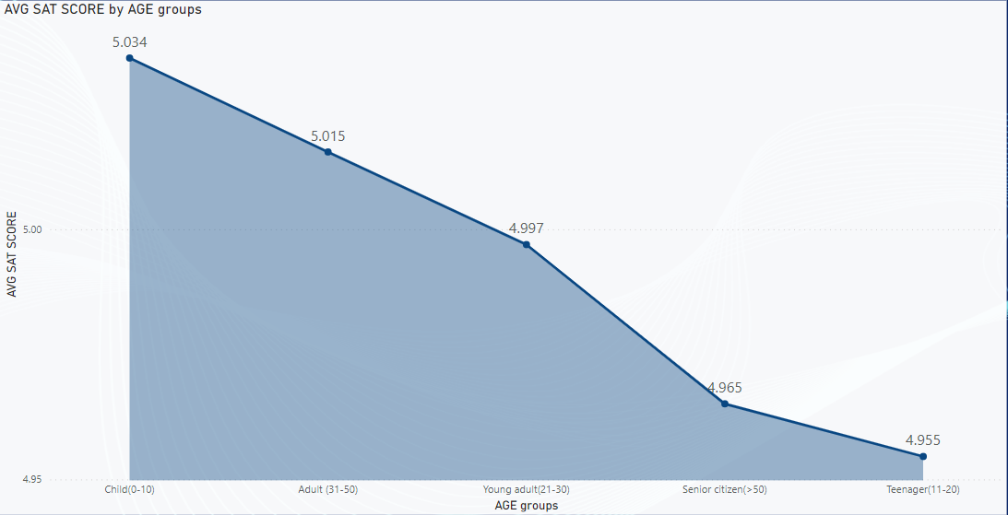

As per the data,

**Age group of children (0-10) can be seen having the highest satisfaction score.**

* There may be several possible reasons for it such as the healthcare issues and services need at such young age except the surgeries are often simpler or OPD specific concerns hence the satisfaction score can be high.
* Generally, people including all the healthcare providers, parents are joyful, positive, in playing mode to make the child comfortable which can lead to a happy child reactions and satisfaction score.
* The high children satisfaction score can also be an indicator of capability, output or excellence of paediatric department doctors which achieved the high score.
* The feedbacks are mostly filled by parents and not the children themselves .

**Age group of adult (31-50) has the second highest satisfaction score and young adult (21-30) age group is roughly same at medium comparative satisfaction with all age groups.**

**Age group of senior citizens (>50) has the second lowest average satisfaction score amongst all age group.**

* Having this low average satisfaction score is point of concern for hospital management and should be taken special care of to maintain and enhance the services in senior citizen age group.
* Population of this age group is sensitive to waiting time at hospital. It may be a indicator for not ample and comfortable services and higher wait time and lower satisfaction scores.
* This age group is more in need of special services and comfortable services due to limitations of the age and special care and arrangements in hospital should exists.

**Age group of teenagers (11-20) has the lowest satisfaction score amongst all the age groups.**

* Having low satisfaction score is a alarming situation for hospital. Along with senior citizens, teenagers have the lowest satisfaction score.
* Measures should be taken for attempt to increase the average satisfaction scores for senior citizens and teenagers
  + Reasons for low satisfaction score for teenagers can be
    - Different communication needs due to the transitioning age group type.
    - No enough Awareness or ignorance regarding healthcare.
    - Unable to communicate the exact issue due to privacy or any other reasons leading to dissatisfaction.

**Conclusion and further action that shall be taken-**

* **Overall,** the average satisfaction scores lie within the range of 4-5 out of 10 which in itself is not satisfactory.
* The scores range for all age groups is ranging in very mediocre range which is a indicator for upgrading and updating for services strategically in hospital.
* First aim of the hospital should be to get all the satisfaction scores nearby the range of 6-8 specially focusing of age groups of teenagers and senior citizens.
* **This can be achieved by,**
  + Tailoring age specific services like more home to home or online options for senior citizens which will make there hospital visits or process easier .
  + Digital services or online services can be added.
  + Awareness campaigns with discounts shall be organized helping teenagers gain deeper insights on health management.
  + More accurate and detailed feedback process should be established and on getting the feedback that should be quickly analysed and if legit then improvement should be made.
  + Staff and hospital manpower should be trained specifically to cater to the every specific age group depending upon their particular needs.
  + Effective communication
  + Effective appointment scheduling process
  + The hospital shall freely and openly provide digital training to especially old aged population as well every age as per needed to use the digital services.
  + The feedback and rating process should be easy and seamless for patients and once the hospital gets feedback the management should quickly act on the information required.

Providing age specific services and catering to age specific needs is very important for improving the average satisfaction score not only for senior citizen but also including every age group collectively.

Question -5

**The hospital management intends to offer discounts to patients.**

The question arises: how should these bonuses be assigned to patients, on what basis, and why?

Ans –

* Discount model shall be practised by hospital as a welfare service and also discount model at hospital can provide tax returns benefits from government which would ultimately help the profitability of hospital revenue.

**Various aspects can be considered while offering the discounts.**

1 - **What is the income groups of the patients** – Patients submitting low-income group documents can be offered discount accordingly.

2- **By Status of insurance** – Many people do not have knowledge of insurance services and benefits and hence don’t purchase a insurance, however when a hospital emergency arise they come under a sudden monetary burden. Hence people not having insurance can be provided with certain packages which are tailored to the benefit of patient as well as hospital.

3- **Military and forces discount** – People which are serving in army/military and their families can be provided with discounts as a contribution to the nation and as a token of thanks for their service.

4- **Packages for employees** – Discounts can be offered to the all-healthcare workers in the hospital. This offer can benefit the sector of healthcare workers which comes under helping department not having huge savings or funds for unprecedented incidents.

5 – **Seasonal discounts** – Discounts on OPD services can be arranged in various seasons or occasions like doctors day, world health day , cancer day ,where the OPD rates on a specific timings are free or kept concessional. This will also help in spreading and growing healthcare awareness.

6 – **Loyalty card patient programs**- Patient which comes to the hospital from a long time , shall be offered a loyalty card on which a collective discounts or points which can be redeemed at the hospital’s various department like pathology, radiology, medicines department. As well referral discount can be made in which when a person having loyalty card refers a new patient, both – the old patient and new patient receive some discounts. This will help contribute to grow the footfall at the hospital.

7 – **Based on timings and doctors –** Doctors who are ready for doing social welfare services and in a stipulated slot when the rush in the hospital is less then by the means of these doctors the OPD fee should be discounted. This would help the patient in terms of availing affordable medical diagnosis and also help in cases where people due to appointment fee charges don’t go to the doctors and self-diagnose and self-medicate.

**8 – Based on footfall(visitors)-**

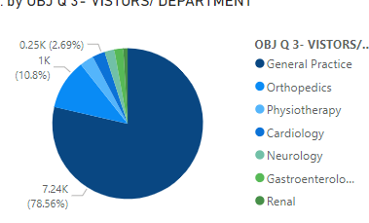

* It can be seen that renal and neurology department has the lowest volume of visitors .
* Hence discount can be made on OPD charges of these department .

**Question -6**

**The hospital has a budget to hire 2-3 new doctors.**

They have asked for your suggestions in which departments they should hire.

**Ans -**

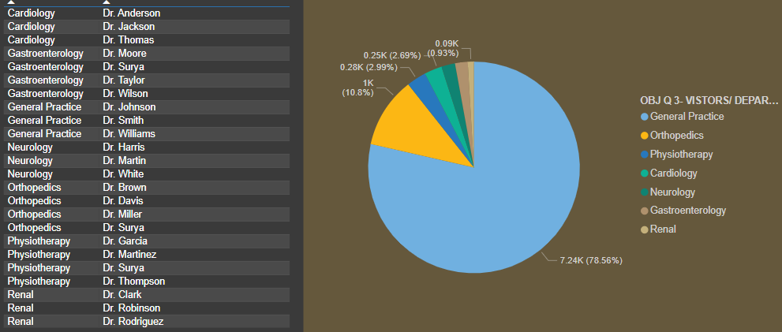

* This is the graph of doctors available for each department and visitors/department.
* As well we will take reference from revenue generation for each department from the graph below.

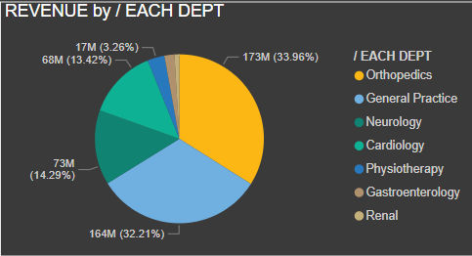

* By analysing the data for doctor available for each department , footfall for each department and revenue generated by each department it can be seen that.
* General practice and orthopaedics department has the most numbers of visitors of 78% and 10 % respectively.
* This 88% of visitors from General practice and orthopaedics department has a chunk of contribution to 32.31% & 33.96% that is total of 66.27% of revenue of total hospital.
* Hence from seeing the list of doctors distribution as per departments it can be said that 3 doctors from general practice that are Dr.Jonhson, Dr.Smith, Dr.Williams and 4 doctors from orthopaedics that are Dr.Brown,Dr.Davis,Dr.Miller,Dr.Surya handles all the footfall of the visitors from these two departments.
* Hence keeping in the mind, the load of footfall and it contribution to revenue to hospital,
* If new hiring of doctors is being done then **General practice and Orthopaedics** would be the needed department to have more numbers of doctors.
* Due to this the load on the pre-existing 7 doctors would be distributed which would help in numerous ways to hospital such as – if more numbers of doctors are there the wait time of patients would be lesser, this would in turn result in better satisfaction score.

**Conclusion-**

* **General practice and Orthopaedic department** would be the best departments for getting new hired doctors to be added looking upon the dynamics of visitors, revenue and current numbers of doctors.

**Question -7**

**Is the hospital profitable?**

**Ans –**

* Establishing and running a hospital is a daunting task due to its nature .

Running a hospital included numerous things and factors like

* The physical capital building
* Maintenance of the structure
* Hiring and salaries of staffs and doctors(constitutes of 40-60 % of net revenue)
* All the supplies - medical supplies, drugs & pharmaceuticals (constitutes of 15-20 % of net revenue)
* Machinery’s
* Utilities cost
* Occupancy and operational cost(constitutes of 5 % of net revenue)
* General and administrative expense including advertising, IT expense, insurance, billing & collecting, finance, equipment expense, executive team, office expenses (constitutes of 5-10 % of net revenue).
* The total revenue of the hospital is reported to be 509 M

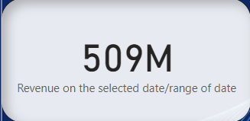

* Below is the graph which shows the distribution of average average operating cost for hospitals in US and its increase over the year. (Tieche, n.d.)

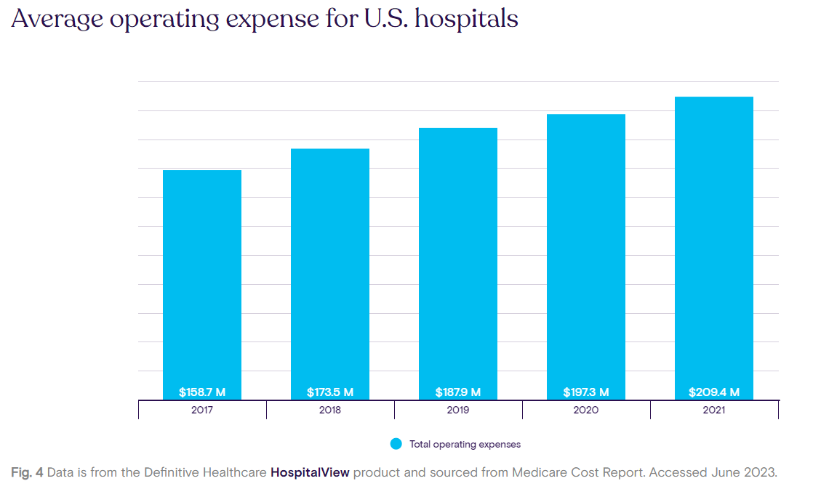

**Calculation of operating cost**

* If we consider the data of 2019 and 2020 then the total average operating cost for a year for a hospital is 187.9M and 197M which means 15.6M in 2019 and 16.41 in 2020 for a month.
* If we corelate this information with information we have , we can derive that from the data we have is of from April 2019 to October 2020 which is we have revenue of 17 months.
* Hospital reported total revenue of 509M for 17 months.
* As per the data available from definitive healthcare reports it can be seen that average per month expense is 15.6M in 2019 and 16.41 in 2020 for a month.
* Therefore for 10 months of 2019 the average operating cost for Asia Columbia hospital can be 156M and for remaining 7 months of 2020 be 114.87 M.
* Hence total operating cost for Asia Columbia hospital can be constituted approximately to 270 M. As we don’t have the exact expenses data available there may be discrepancies in the operating cost of roughly 5-10% +- M.
* Hence we can say that the **OPERATING COST** of the hospital as **300M**.
* Other than this there are certain costs like capital expenditures, technological upgrades , Research & development miscellaneous which can contribute to 20-30% of revenue. Which according to our data would result to **130M.**
* Whereas the hospital has reported the revenue of 509M.
* And the total amount of estimated expense to be 430M

**Conclusion-**

Yes, the hospital seems to be profitable and this profit can be used for adding various new services , and allocating money to departments of research and development to the hospital and can be used to the benefit of growth of the hospital.

**Question -8**

**Any Department for which the waiting time is oddly large?**

**Ans-For** analysing the wait time , the following bar chart can be looked 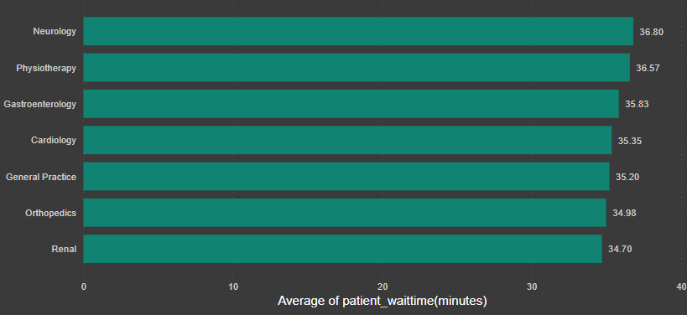

**The** highest wait time for patient is for the neurology department and lowest wait time is for the renal department. But the difference between highest and lowest is not a considerable odd amount. Hence more or less the wait time for all the departments are nearly the same. This suggests that the average wait time is almost same for every department that means there is no issue from the side of doctor but somewhere in the process in registration , taking appointment, locating OPD that is inpatient and out patients services to be looked pon to improve for lowering the average wait time.

**Conclusion -**

**No,** the wait time for all department lies near the average wait time of 35minutes.   
There is no such department having oddly large waiting time.

However it suggest that there can be issue in some of the processes of hospital as to every department the average wait time is nearby the same hence if this particular faulty or time taking process if identified then the average waiting time can be lowered.

**Question -8**

**Come up with the strategies to provide discounts to the patients.**

**Ans –**

**V**arious basis that were listed in the subjective question number 5 for those basis below mentioned strategies can be used.

1 - **What is the income groups of the patients** – Patients submitting low-income group documents can be offered discount accordingly.

* **Strategy – When** patient come for the registration at OPD counter, the receptionist shall provide a option to patient if he wants to make the registration in the concessional option for income group specified under a limit.
* But for this the patient shall have to provide his ID card and any income proof which would help as a document in proving that the patient has a monthly/yearly income less than the permissible limits for the discounts/concession.

2- **By Status of insurance** – Many people do not have knowledge of insurance services and benefits and hence don’t purchase a insurance, however when a hospital emergency arise they come under a sudden monetary burden. Hence people not having insurance can be provided with certain packages which are tailored to the benefit of patient as well as hospital.

* **Strategy –** When the patient arrives in the hospital , after the OPD appointment if the further course of action suggested by doctor is a expensive one such as admitting the person to hospital or expensive procedures or tests in hospitals then the patient should be asked if he/she has insurance.
* Now if he has a pre-existing insurance then not an issue , but the strategy comes in picture if the person don’t have the insurance then hospital can design 2 major options for patients like partnering with a insurance company and providing insurance to the patient but in most of the cases insurance takes time to get active hence the other option if the patient does not has the time and the procedure has to be done immediately then hospital can preplan their own discount packages which would help to ease the sudden monetary burden to patient.

3- **Packages for employees** – Discounts can be offered to the all-healthcare workers in the hospital. This offer can benefit the sector of healthcare workers which comes under helping department not having huge savings or funds for unprecedented incidents.

* **Strategy-** As employees contributes to be the major working force in the hospital setup. Hence, discount on various services of hospital can be provided to them as well full discount can be provided to them in the OPD appointment.
* More percent of discount can be availed as per the post of the healthcare worker that is lower the post greater the discount and vice versa.

5 – **Seasonal discounts** – Discounts on OPD services can be arranged in various seasons or occasions like doctors day, world health day, cancer day ,where the OPD rates on a specific timings are free or kept concessional. This will also help in spreading and growing healthcare awareness.

* **Strategy-**
* **In the yearly** calendar plan , discounts and concessions can be pre planned such as on cancer day free cancer check-ups can be organized, on women’s day – free OPD consultation for women’s, and same for males on men’s day .

6 – **Loyalty card patient programs**- Patient which comes to the hospital from a long time , shall be offered a loyalty card on which a collective discounts or points which can be redeemed at the hospital’s various department like pathology, radiology, medicines department.

**Strategy-**

* When a person would come ,if the person has a loyalty card then a points credit system can be established .
* In this ,the person would receive comparative points as per his hospital expenses bill.
* This point gained on the payment when reaches a certain limit after 4-5 apoointments then this would be redeemed after a certain limit on various hospital services.